CIS Benchmark Compliance Assessment Report

Microsoft Windows Server 2022 – Account Policies

1. Overview of the CIS Benchmark and Its Importance
The Center for Internet Security (CIS) Benchmark is a globally recognized set of security configuration guidelines developed through collaboration among cybersecurity experts, government agencies, and industry professionals. These benchmarks provide best practices for securely configuring operating systems, applications, cloud services, and network devices while maintaining system functionality.
The CIS Benchmark for Microsoft Windows Server 2022 offers detailed recommendations to strengthen the operating system against common security threats such as brute-force attacks, password compromise, unauthorized access, and privilege abuse. Organizations adopt CIS Benchmarks as a security baseline because they reduce the system’s attack surface, promote standardized configurations, and assist in meeting regulatory and compliance requirements.
Within the scope of this project, the benchmark was used to evaluate and configure the Account Policies of a Windows Server 2022 virtual machine. The assessment focused on Password Policy and Account Lockout Policy to improve authentication security and align the system with recognized cybersecurity best practices.

2. Comparison of Existing Account Policies with CIS Benchmark Recommendations
The Local Security Policy (secpol.msc) was reviewed to examine the default Account Policy configuration of the Windows Server 2022 installation. The existing settings were then compared with the recommendations specified in CIS Benchmark v3.0.0.

Password Policy
Security Policy | Default Configuration | CIS Recommended Configuration | Final Configuration | Compliance
Enforce Password History | 0 passwords remembered | 24 passwords remembered | 24 passwords remembered | Compliant
Maximum Password Age | 42 days | 365 days | 365 days | Compliant
Minimum Password Age | 0 days | 2 days | 2 days | Compliant
Minimum Password Length | 0 characters | 14 characters | 14 characters | Compliant
Minimum Password Length Audit | Not Defined | 14 characters | 14 characters | Compliant
Password Complexity | Enabled | Enabled | Enabled | Compliant
Relax Minimum Password Length Limits | Not Defined | Enabled | Enabled | Compliant
Store passwords using reversible encryption |  | Disabled | Disabled | compliant

Assessment
The default password policy contained several security weaknesses, including unrestricted password reuse, no minimum password length, and no minimum password age. These settings could increase the likelihood of weak passwords and password reuse. After implementing the CIS recommendations, the password policy enforces stronger authentication controls that significantly improve password security.

Account Lockout Policy
Security Policy | Default Configuration | CIS Recommended Configuration | Final Configuration | Compliance
Account Lockout Threshold | 0 invalid attempts | 5 invalid attempts | 5 invalid attempts | Compliant
Account Lockout Duration | Not Applicable | 15 minutes | 15 minutes | Compliant
Reset Account Lockout Counter After | Not Applicable | 15 minutes | 15 minutes | Compliant

Assessment
The default configuration did not enforce account lockout protection, allowing unlimited authentication attempts. This exposed the system to brute-force password attacks. After applying the CIS recommendations, the system automatically locks an account after five consecutive failed login attempts for a period of fifteen minutes, thereby strengthening authentication security.

3. Specific Changes Made to Align with the CIS Benchmark
The following security configurations were implemented to achieve compliance with CIS Benchmark v3.0.0:

Password Policy
- Configured password history to remember the previous 24 passwords.
- Increased the maximum password age from 42 days to 365 days.
- Configured the minimum password age to 2 days.
- Increased the minimum password length from 0 to 14 characters.
- Configured the minimum password length audit value to 14 characters.
- Enabled the Relax Minimum Password Length Limits setting.
- Verified that Password Complexity Requirements remained enabled.
- Verified that Store Passwords Using Reversible Encryption remained disabled.

Account Lockout Policy
- Enabled the Account Lockout Policy.
- Configured the account lockout threshold to 5 invalid login attempts.
- Configured the account lockout duration to 15 minutes.
- Configured the reset account lockout counter after 15 minutes.
These modifications successfully aligned the Windows Server 2022 Account Policies with the CIS Benchmark recommendations and improved the overall security posture of the system.

4. Challenges Encountered During the Process
Several practical challenges were encountered while completing the assessment and configuration.
Initially, understanding the CIS Benchmark documentation required careful examination because each recommendation is presented alongside technical descriptions, implementation guidance, and rationale. Identifying the corresponding settings within the Windows Local Security Policy also required familiarity with the operating system’s administrative tools.
Another challenge involved comparing the default Windows Server configuration with the benchmark recommendations to determine which settings required modification. Some policies, such as password complexity, were already compliant, whereas others required significant changes.
Finally, each configuration was verified after implementation to ensure that the applied settings accurately reflected the CIS Benchmark recommendations and that no configuration errors were introduced during the process.

5.Before and After screen shots

Password policy before configuration
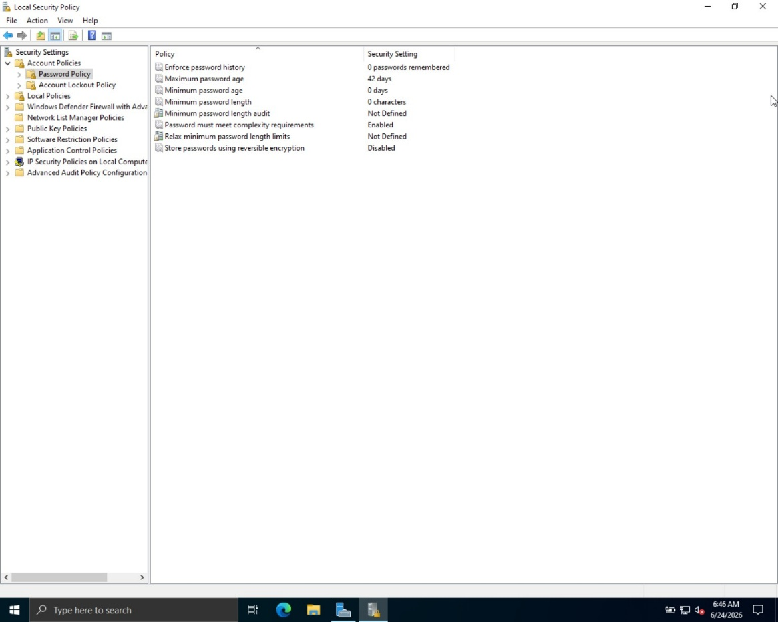

Password policy after configuration
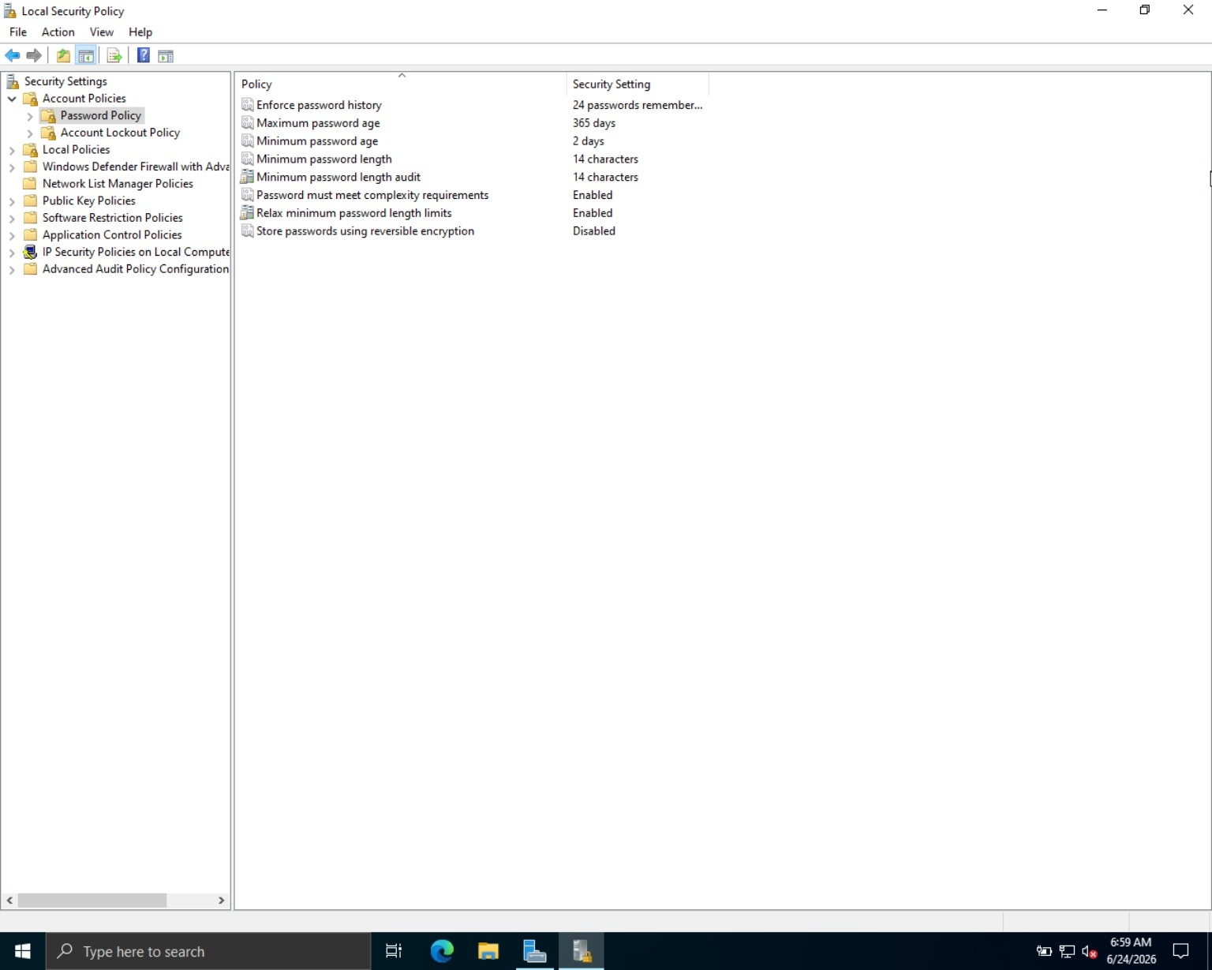

\

Account lockout policy before configuration
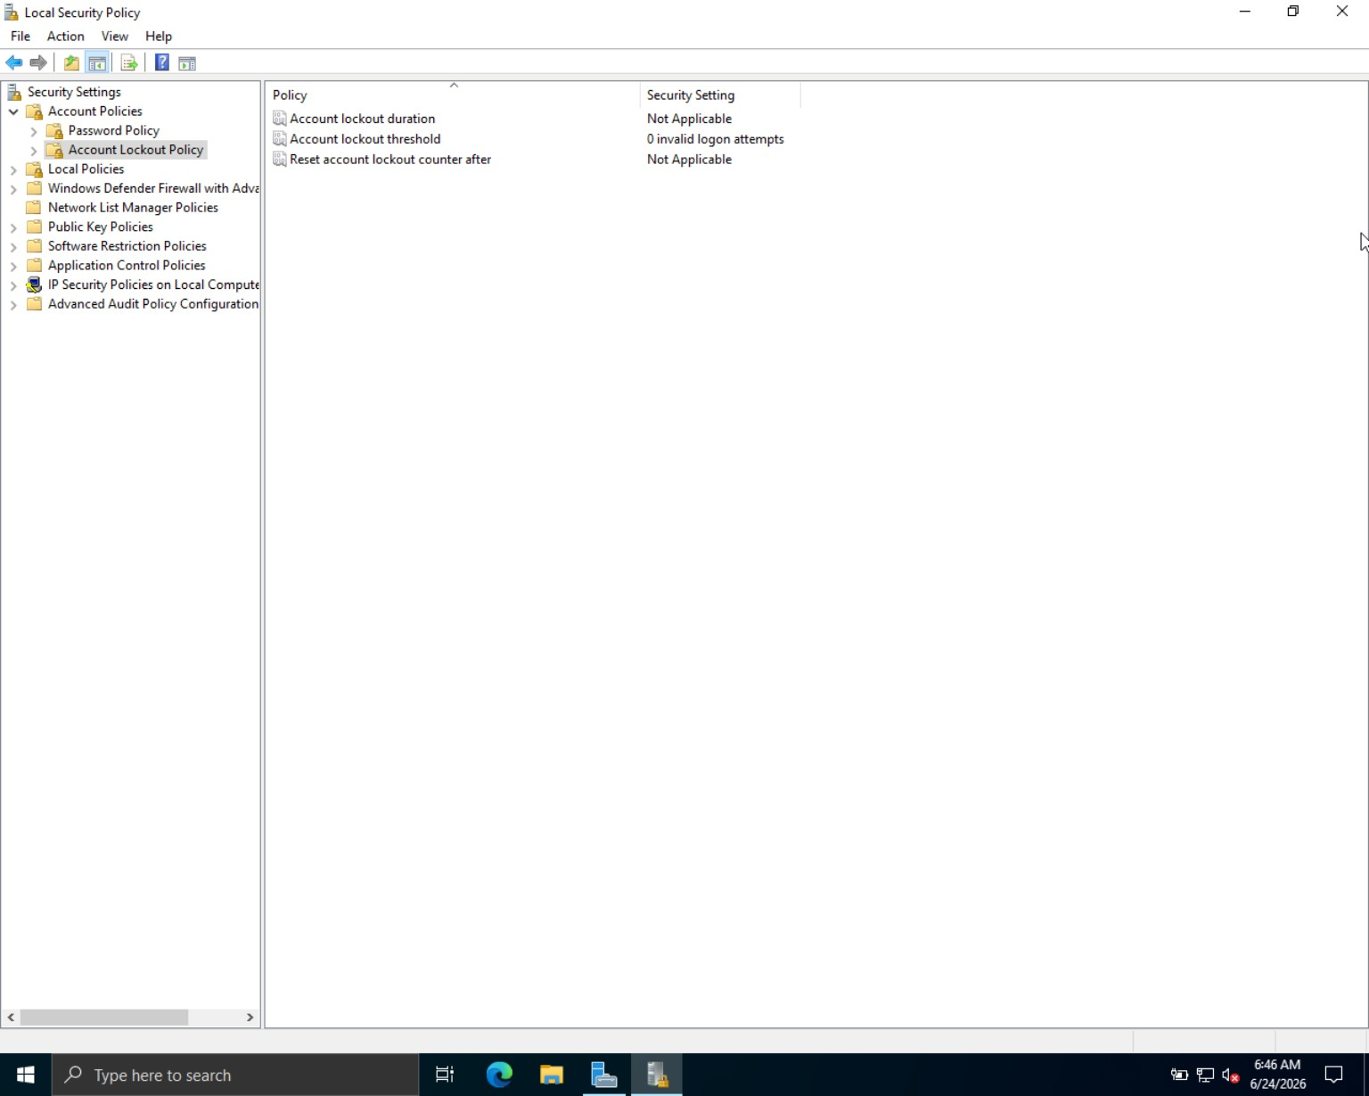

Account lockout policy after configuration
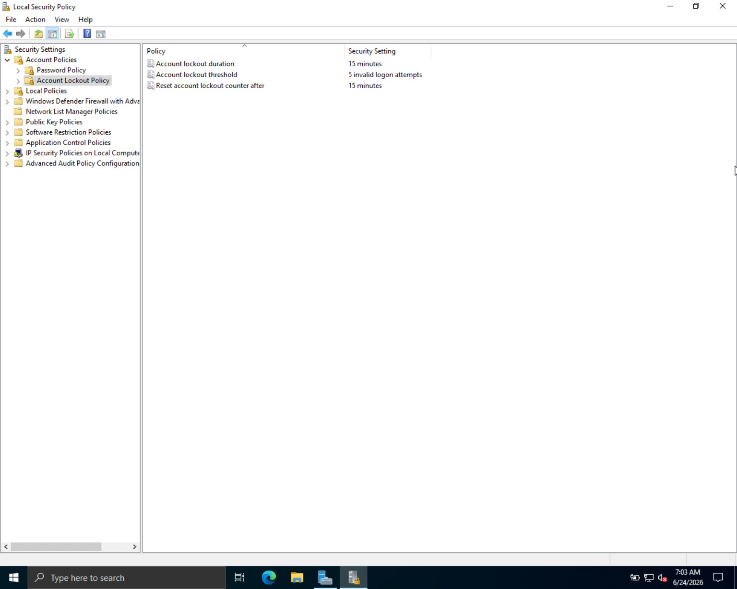

Conclusion
The assessment successfully evaluated and configured the Password Policy and Account Lockout Policy of Microsoft Windows Server 2022 in accordance with CIS Benchmark v3.0.0. The implemented security controls strengthened password management, prevented password reuse, enforced stronger authentication requirements, and protected the system against brute-force attacks through account lockout mechanisms. The completed configuration demonstrates compliance with established cybersecurity best practices and provides a stronger security baseline for Windows Server deployments.

